ARC Restoration Launches New Website to Provide

Comprehensive Support for Property Emergencies

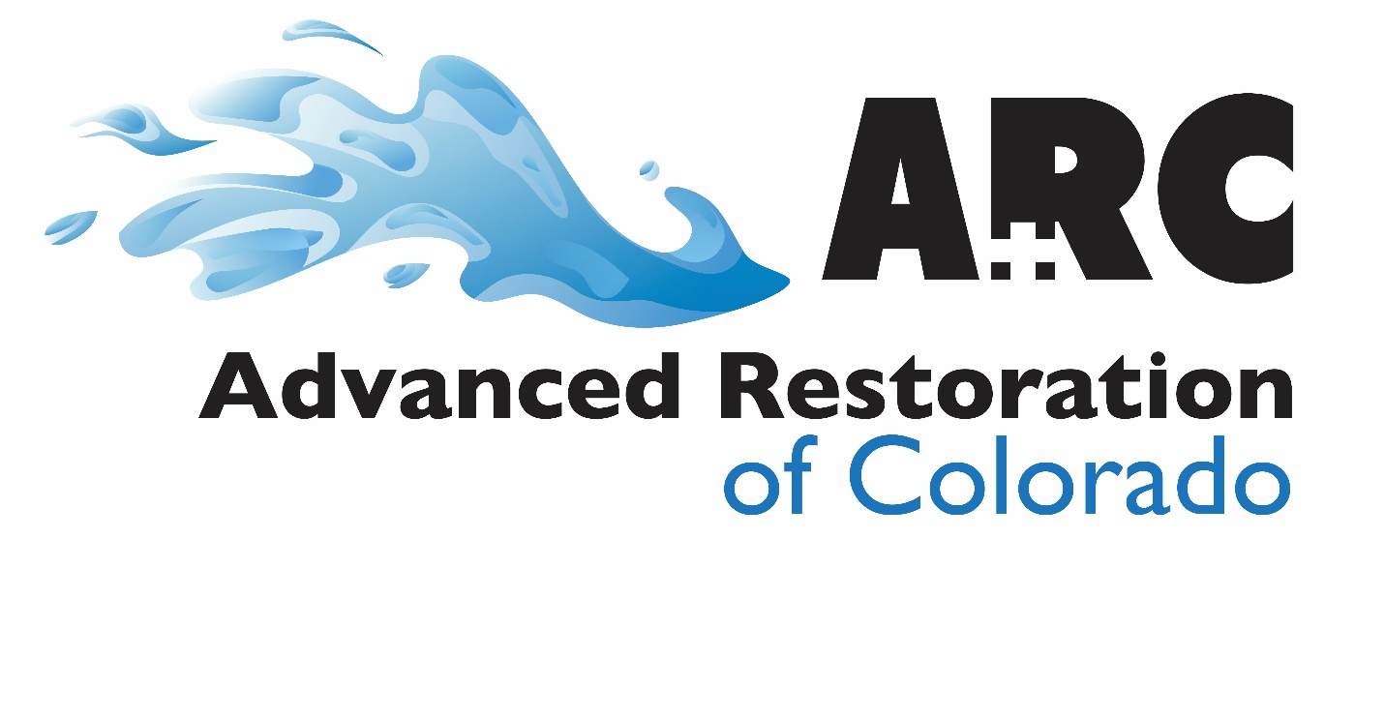
ARC Restoration, a trusted and reliable company specializing in disaster cleanup and restoration services, is pleased to announce the launch of its updated website, https://advancedrestorationcolorado.com/. The new website is designed to provide valuable information and resources to help clients deal with emergencies such as floods and fires effectively.
ARC Restoration understands that when disaster strikes, it can be a stressful and overwhelming time. That’s why they offer prompt restoration services to provide clients with peace of mind during these challenging situations. Whether it’s fire, smoke, mold, or water damage, ARC Restoration prioritizes immediate cleanup and restoration to mitigate further harm to your property.

The new website aims to serve as a comprehensive platform for clients to access essential information and solutions for dealing with property damage emergencies. It features detailed information about the various disaster cleanup and restoration services offered by ARC Restoration, including water mitigation, fire damage restoration, smoke damage restoration, mold remediation, and more. Clients can also find valuable resources and tips for handling property damage emergencies effectively.

One of the key features of the new website is the emphasis on the long-term benefits of professional disaster cleanup and restoration. ARC Restoration is committed to providing reliable solutions that not only address the immediate damage but also contribute to the long-term restoration and preservation of the property.

In addition to providing information about the services offered, the website also highlights the company's commitment to customer satisfaction and its 24/7 emergency assistance, ensuring that clients receive prompt and reliable support when disaster strikes.

"We are excited to launch our new website, which is aimed at providing our clients with a valuable resource for dealing with property damage emergencies. Our goal is to alleviate stress and provide reliable solutions during challenging times, allowing our clients to regain a sense of normalcy," said Chris Barnett, owner of ARC Restoration.

The new website will feature case studies and testimonials to showcase the company's track record of delivering exceptional results and excellent customer service. Clients can gain insights into the successful restoration projects undertaken by ARC Restoration, further reinforcing the company's commitment to restoring properties to their optimal condition.

With the launch of the new website, ARC Restoration aims to enhance its online presence and provide a user-friendly experience for clients seeking information and assistance with property damage emergencies. The website has been designed to offer improved navigation and functionality, allowing clients to easily access the information they need to make informed decisions during challenging times.
"We are thrilled to introduce our new website, which is designed to be a valuable resource for our clients in managing property damage emergencies. Our primary objective is to alleviate stress and provide reliable solutions during challenging times, enabling our clients to regain a sense of normalcy," said Chris Barnett.

ARC Restoration sets itself apart from other restoration companies through several key factors.
Prompt and Comprehensive Restoration Services: ARC Restoration prioritizes immediate cleanup and restoration to mitigate further harm to clients' properties in the event of disasters such as fire, smoke, mold, or water damage. The company offers a wide range of services, including water damage remediation, fire damage restoration, mold remediation, and biohazard cleanup. This comprehensive approach ensures that every aspect of the damage is addressed, setting ARC Restoration apart in its commitment to providing complete solutions for property restoration.

Customer-Centric Approach: ARC Restoration places a strong emphasis on customer satisfaction and aims to provide exceptional results along with excellent customer service. The company thrives on friendly communication and is dedicated to creating a healthy and safe environment for the local community. This commitment to customer service and community well-being distinguishes ARC Restoration as a company that prioritizes the needs and satisfaction of its clients.

Professionalism and Industry Compliance: ARC Restoration is a licensed contractor that meets industry standards and regulations, ensuring that customers receive high-quality results while prioritizing safety protocols. This commitment to professionalism and adherence to industry standards sets ARC Restoration apart as a reliable and trustworthy restoration company.

For more information about ARC Restoration and its comprehensive disaster cleanup and restoration services, visit the new website at https://advancedrestorationcolorado.com/.

About ARC Restoration:
At ARC Restoration, our mission is to create a healthy and safe environment for the local community. We achieve this by providing premium restoration, mitigation, and recovery services using industry-leading processes and high-quality products.

Contact ARC Restoration:
Chris Barnett
4301 South Federal Boulevard, Suite 111 Sheridan, CO
80110
720‑664‑7765
office@advancedrestorationcolorado.com
https://advancedrestorationcolorado.com/

